The Mitnick Attack Lab

Lab Setup:

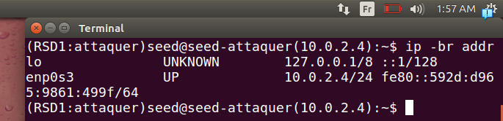
.attacker machine
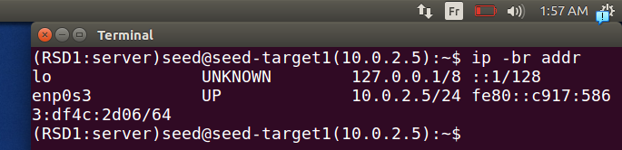
.trusted server machine
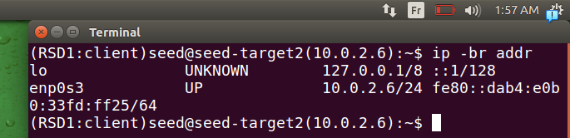
.x-terminal machine
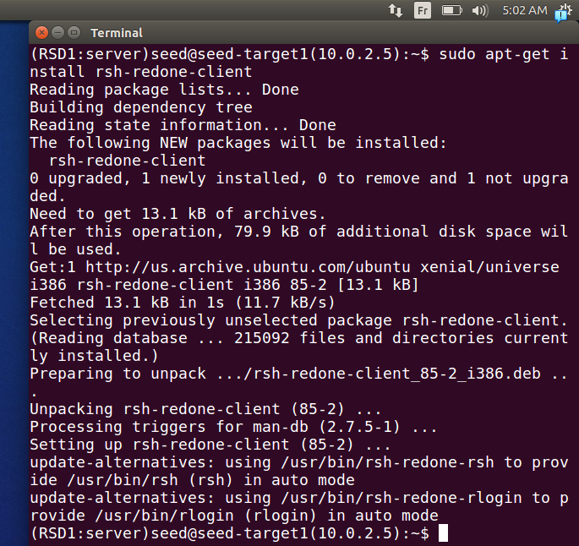
.we install to use rsh client side because trusted server connect to x-terminal, we install it on attacker, and trusted server machines
.we install rsh server on x-terminal machine
in our settings we installed it in all machines to test
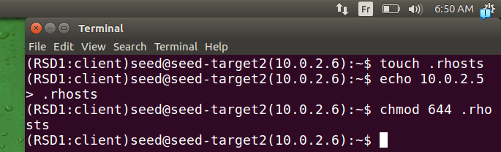
.we create a file .rhost that will contain ip addresses of trusted machine and we change it to 644 because owner only can read, write
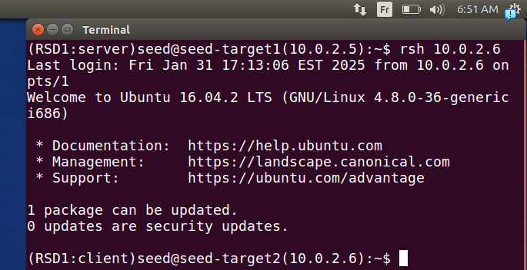
.now we can connect to x-terminal
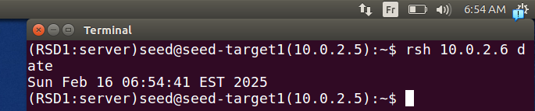
.here we exec a command and it works fine

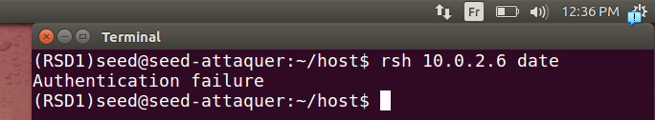
here we cannot connect to x-terminal from attacker machine because it doesn’t work

Task 1: Simulated SYN flooding

.
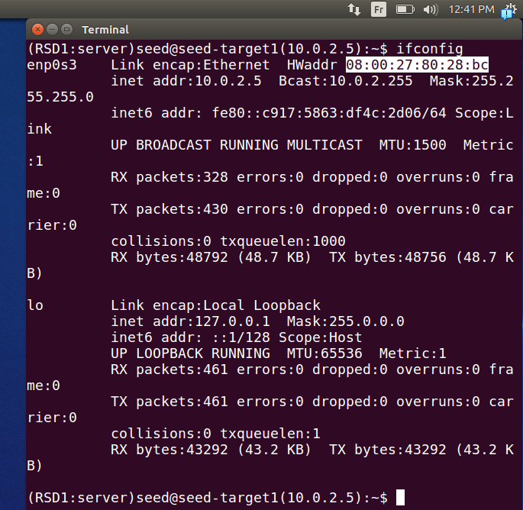
.here we find the mac address of server machine that we will use it later
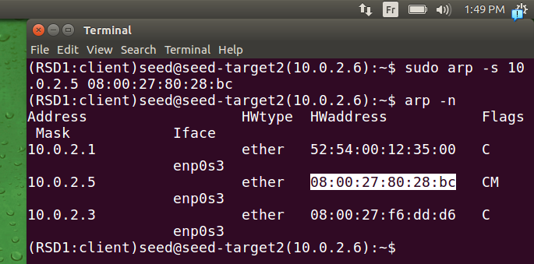
.here we add it permanantly the mac address of machine server machine because if we don’t adde it permanently he will ask who has and none will response to arp request if asked about it’s mac address the reason is our server trusted will be diconnected (in reality we lunch a syn floding to take it down)
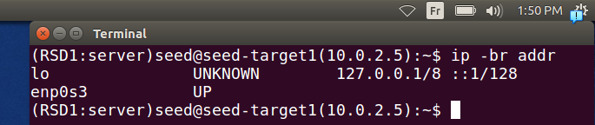
.here we dicconnect the trusted server machine to simulate the flooding attacker
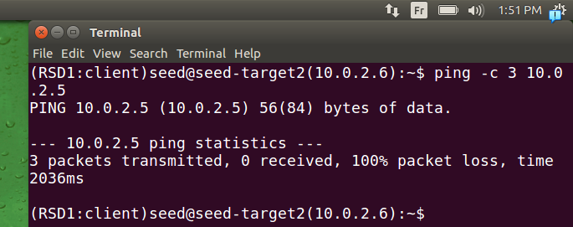
.we try to ping server machine it doesn’t work, so the server stopped correctly
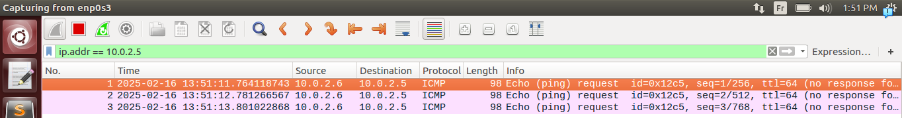
.here we can see that no response

Task 2: Spoof TCP Connections and rsh Sessions

Explain
.
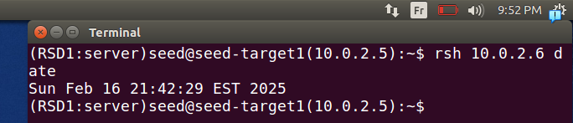
.here we connect again just to test, we lunch a command
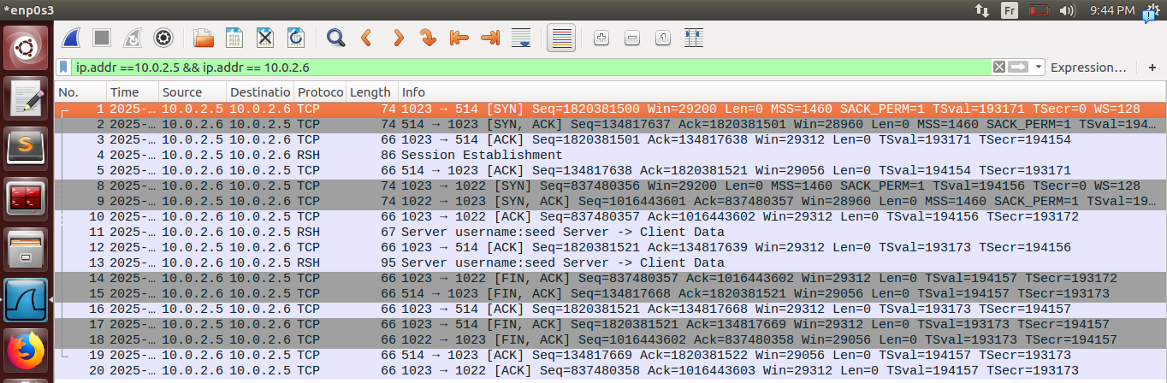
.we can see the packets here :
1→3 : 3 way hanshakes
4: session establishement for command connection(we lunch the command)
5:here we ack the messaage 4
8:initiate the error connection from machine x-terminal to server
9→10 other paquets for the three way handshake
11: going back to first connection
12:ack of packet 11
13:respond to the command (result)
14→20 : ending the connection
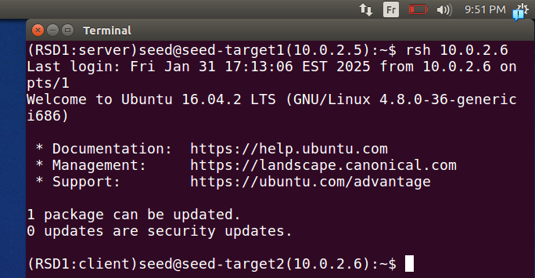
.here we try to connect and see the behavior
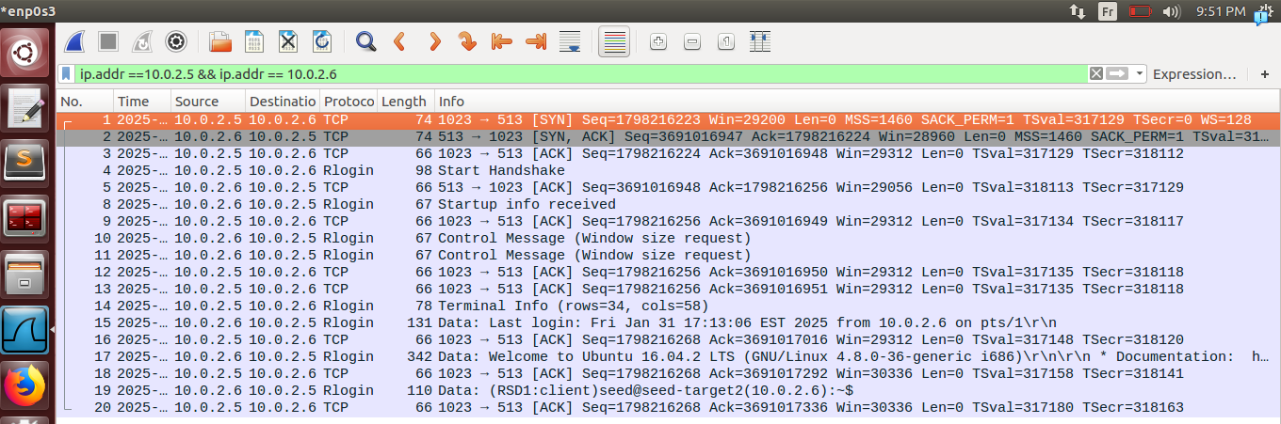
.it’s the same behavior
.here if try to connect with attacker machine (untrusted one)
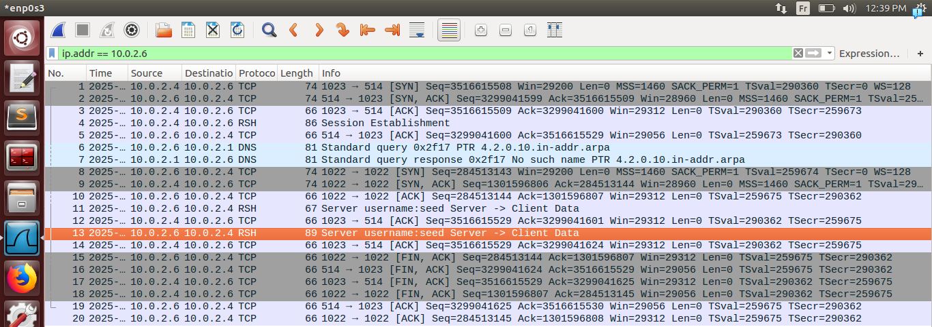
.it will follow the same procedure and connections and until last step that it told that it’s incorrect and then it stop the connections .

Task 2.1: Spoof the First TCP Connection

Step 1: Spoof a SYN packet.
.note that we turned it down again the trusted server machine to simulate the syn flooding attack
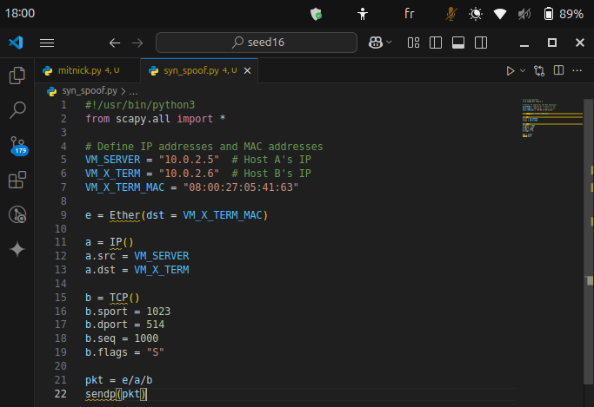
.here we make a code that spoofs the first syn (start a connection -3 way hanshake-) we use the specified port 514
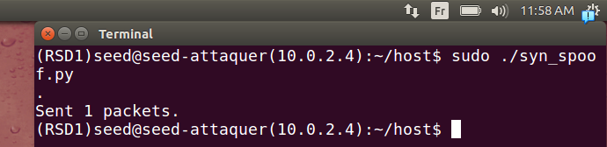
.we lucnh our script from attacker machine
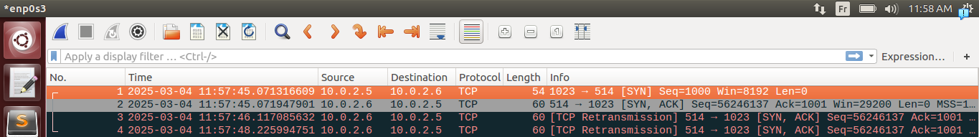
.here we can see that we got a syn+ack response to server machine (note that if we didn’t make the mac permanently of trusted server it will work fine for some time but after it will do an arp request again and will not get a response)

Step 2: Respond to the SYN+ACK packet.
.just to take notice before writing our script
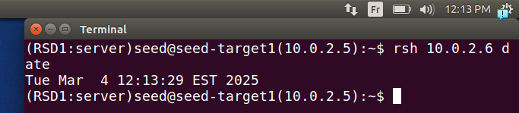
.we try it in real trusted server and see what should we send (packet 3)
.from trusted server to x terminal and the seq, ack can be seen now we can get a grip on how to make script .
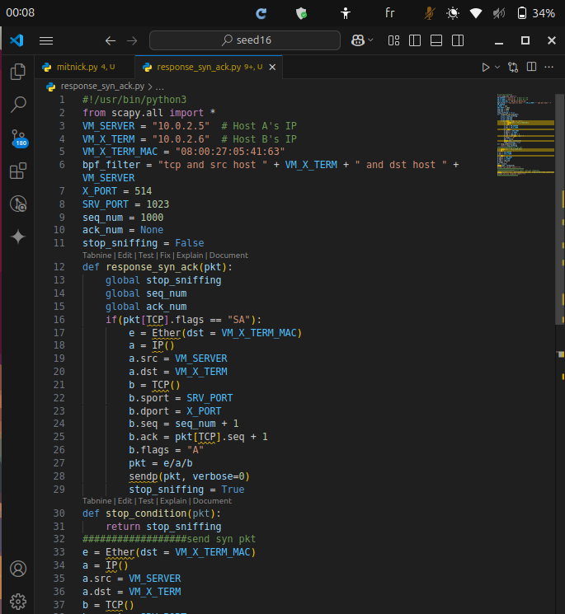
.
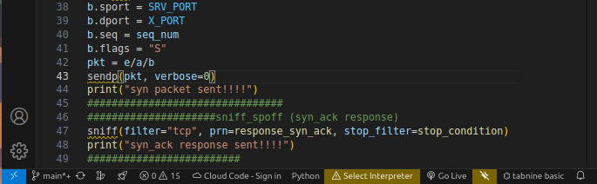
.in script after sending the syn packet we sniff the network packets tcp going from x terminal to server inside the function we need to see the flags yes we got a tcp packet going correctly but we need it to be precicely the syn+ack packet then if send the packet we use the stop condition to stop, note that SYN flag add 1 to seq numbers.
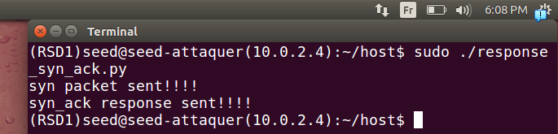
.if we lunch our script now
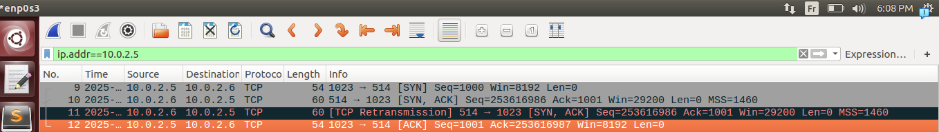
.we can see our ACK packet but note that the retransmission is caused by the latency of python it took time to set up the listenning.

Step 3: Spoof the rsh data packet.
.to demonstrate again we advance
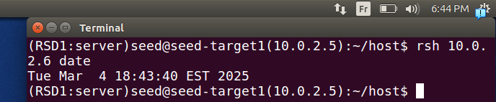
.here if we lunch
.here we capture the packet that we will analyze to write similar to it in our script
.we see seq, ack didn’t advance because only SYN and FIN flags that adds one to them and payload of course
if we access remote shell field we will find our command
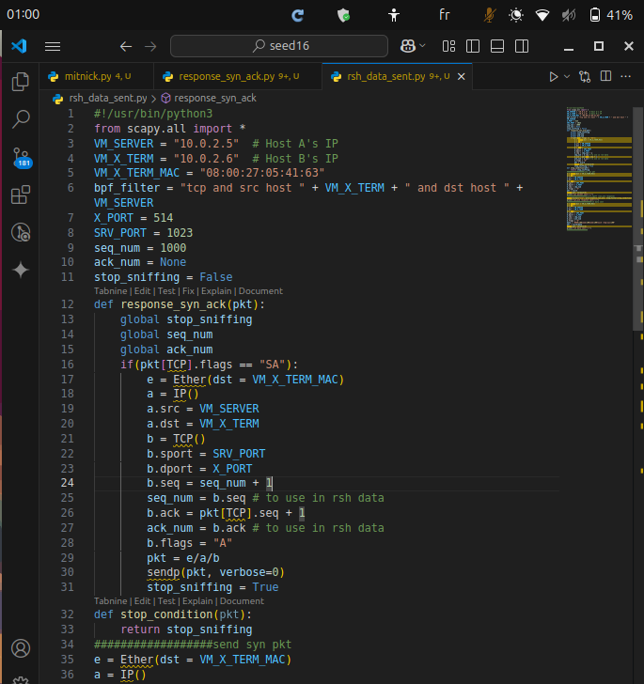
.

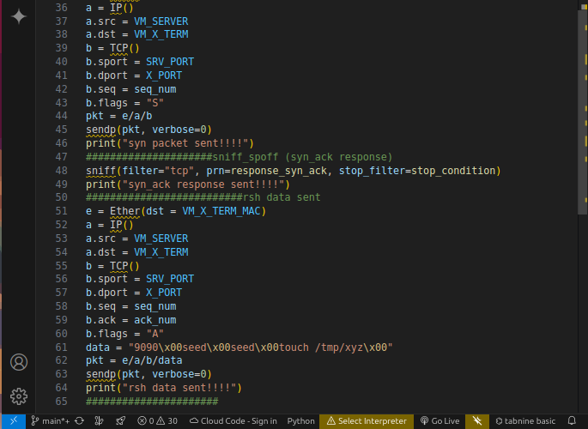
.here because we don’t wait for a packet we don’t sniff but send a packet directly after the ack it should be noted the seq, ack are the same this will not be executed until we establish the second connection, and the command “data = ’9090\x00seed\x00seed\x00touch /tmp/xyz\x00’ the first seed is the user requesting, and seed the user that we will be using there, (we need to specify them correctly not to let the packet work but for the command to work)
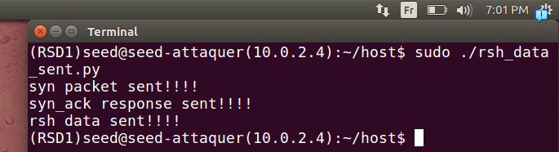
if lunch our script.
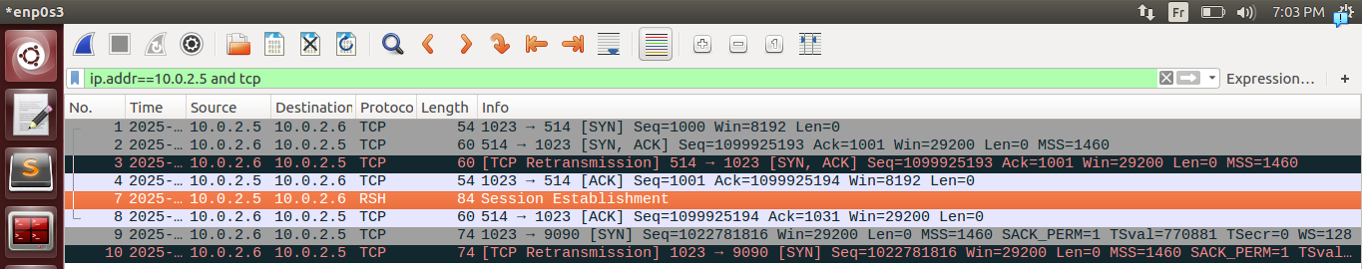
.we can see that it works fine and he is sending an ack of our packet, than sending a syn to lunch the connection of errors (the x terminal machine initiate this connection to the port that we give )

Task 2.2: Spoof the Second TCP Connection
.for demonstrating again
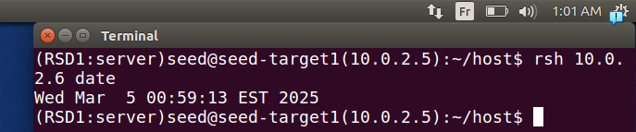
.if we trusted server we can see that we just need to send a syn+ack packet
.
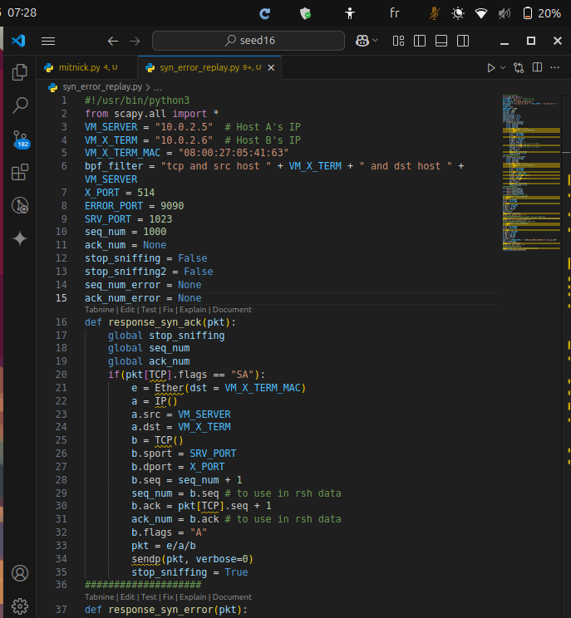
.
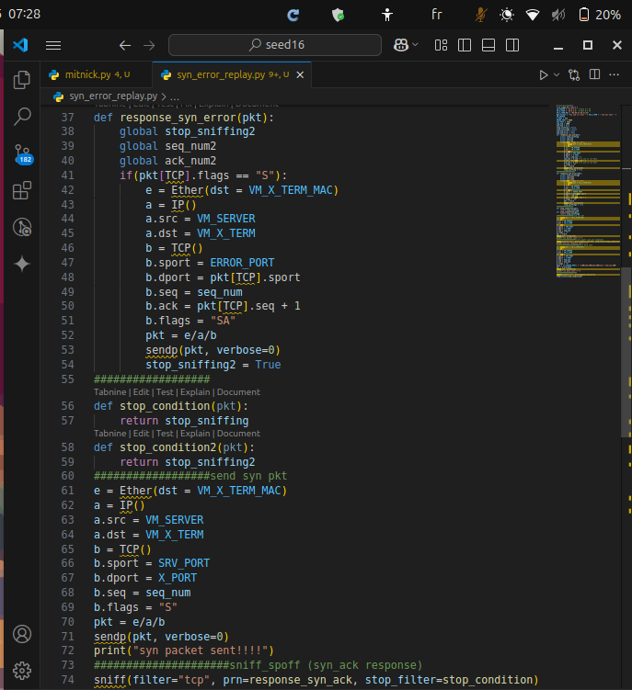
.
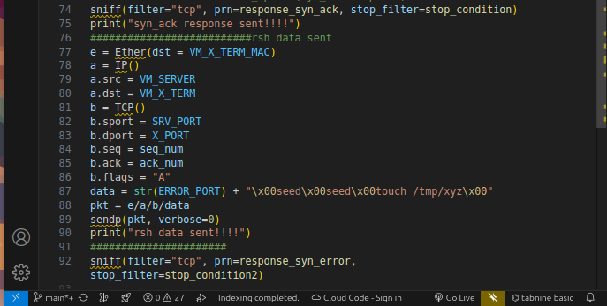
.in the end we sniff for the packet again but with packet flag set to S because it’s init message of the 3 way hanshake so we made syn+ack packet to response
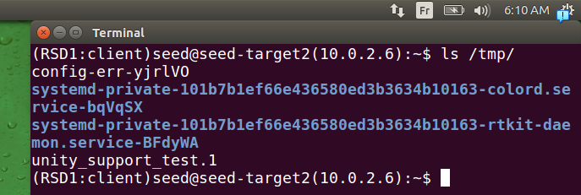
.if we see in our x terminal machine we don’t have xyz file yet
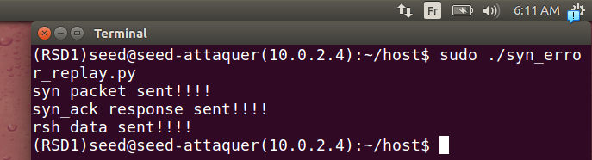
.if we lunch our script
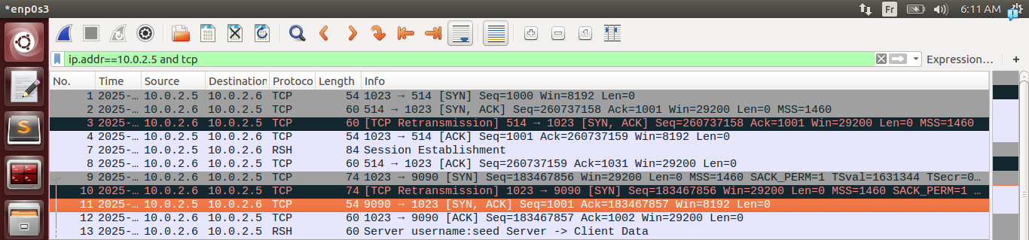
.we can see that it worked fine and we an ack of the packet and result of the command
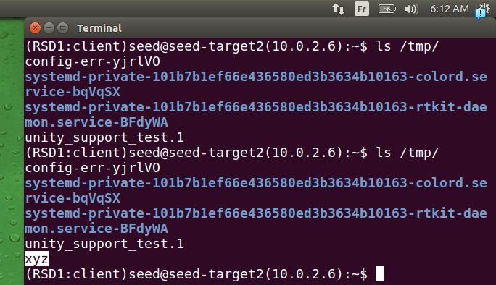
.if we verify we can see that it created with success
if we use echo ‘hello’ we can see result in last packet before FIN of session:
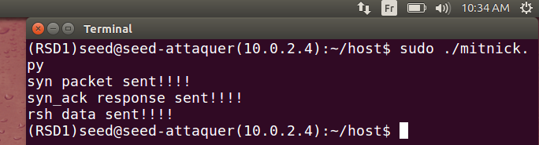
.here we lunch our script with the command echo ‘hello’
.
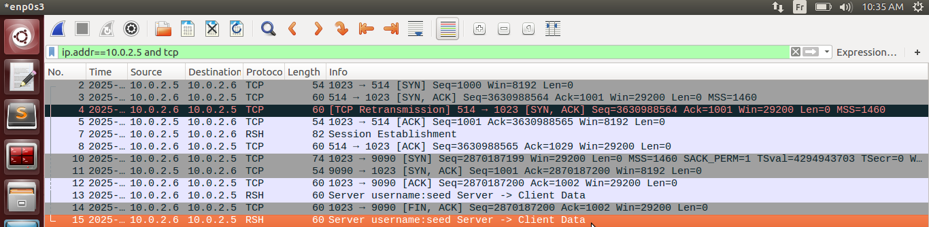
.here if we see the last packet
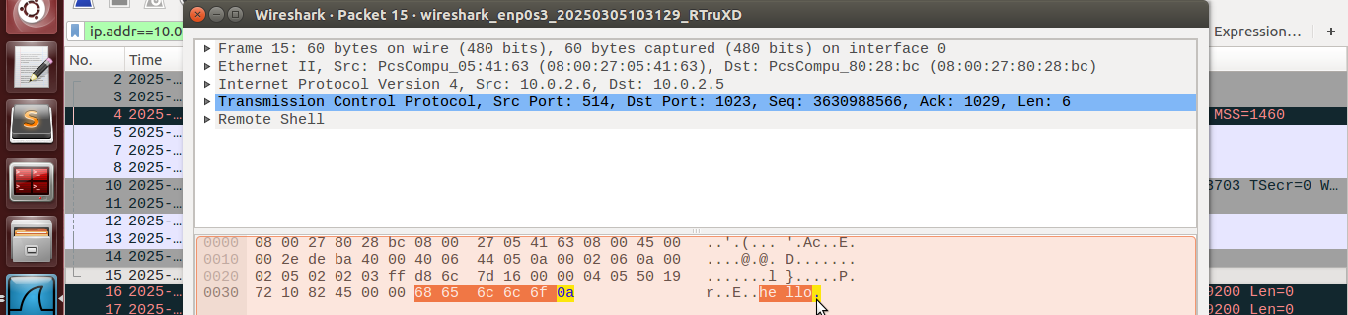
.we can see the response as we told ‘hello’ message

Task 3: Set Up a Backdoor
.we changed the command to “echo + + > .rhosts” it will give access to any machine that wants to connect without password
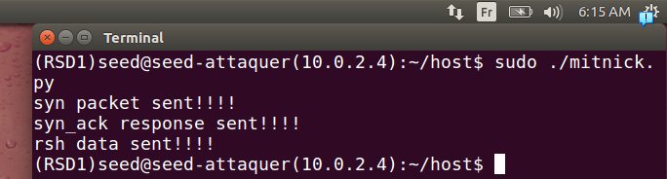
.we lunch our script

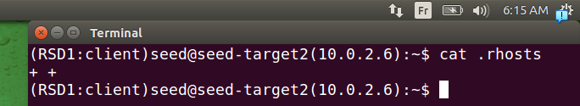
.we can see file changed in x terminal it worked fine
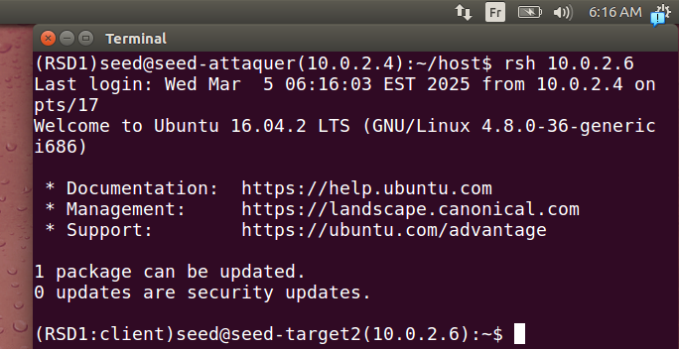
.we can see the result we connected with success

